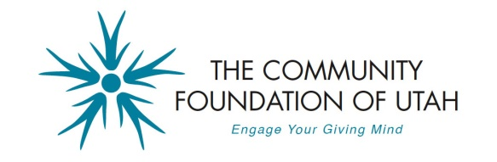
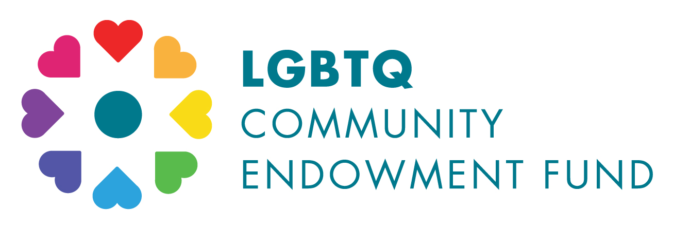

LGBTQ Community ENDOWMENT Fund
2017 GRANT Application Information

The LGBTQ Community Endowment Fund is a component fund of the Community Foundation of Utah and aims to strengthen Utah’s lesbian, gay, bisexual, transgender, and queer (LGBTQ) community by awarding grants for programs that enhance the lives of LGBTQ people in Utah.

Eligibility and Criteria
- Grants are available for nonprofit organizations that support Utah’s LGBTQ community.
- All organizations that receive grants from the fund must:
  - recognize the LGBTQ Community Endowment Fund as the grant source;
  - have a nondiscrimination policy that includes sexual orientation and gender identity; and
  - submit impact reports regarding the use of the grant.
- Preference will be given to programs that:
  - are startups and/or engage in innovative work;
  - increase the LGBTQ community’s access to public services;
  - build the LGBTQ community and promote awareness of and respect for LGBTQ individuals and their impact on the common good; and
  - foster collaboration and promote constructive dialogue between LGBTQ individuals and the community.

The Process
- Applications will be accepted through June 30, 2017.
- The fund committee will initially screen applications. Finalists will then be chosen to present their program at an event the evening of August 29, 2017 where grant awards will be decided.
- Grants typically range from $1,000 to $5,000.

Submission information:
- Complete and return the application to: lgbtq@utahcf.org
- Or mail to the following:
Community Foundation of Utah
Attn: LBGTQ Community Endowment Fund
2257 South 1100 East, Suite 205
Salt Lake City, UT 84106
- Include the following attachments:
  - Organization’s annual operating budget;
  - Most recent financial statement;
  - Detailed budget for the program for which you are requesting the grant;
  - Proof of current 501(c)3 tax-exempt status;
  - List of organization’s current staff and board of directors;
  - Numeric breakdown showing the diversity of the staff and board; and
  - Copy of organization’s nondiscrimination policy that includes sexual orientation and gender identity (or specify if you do not have one and need assistance adopting one).
- Questions may be directed to lgbtq@utahcf.org or by calling 801.559.3005

LGBTQ Community Endowment Fund
2017 GRANT APPLICATION

Organization Information
Name: Click here to enter text.
Mission: Click here to enter text.
Website: Click here to enter text.
Organization annual budget: Click here to enter text.
Populations served: Click here to enter text.
Programs and services offered: Click here to enter text.
Number of clients served in 2016: Click here to enter text.
Geographic area covered: Click here to enter text.

Contact Information
Name, title: Click here to enter text.
Mailing address: Click here to enter text.
Email: Click here to enter text.
Phone: Click here to enter text.

Program Information
Program name: Click here to enter text.
Program budget: Click here to enter text.
Amount of funding requesting: Click here to enter text.

Please be brief (2-3 sentences) in your responses to the following questions:

1. Provide a short description of the program for which you are requesting funds.
Click here to enter text.

2. Describe the specific goals and objectives of the program.
Click here to enter text.

3. What are the activities planned to meet the goals and objectives of the program? (Please include associated timeframes.)
Click here to enter text.

4. What is the expected impact of the program? Describe how the program will be evaluated.
Click here to enter text.

5. List other funding sources for this program and the status of the funds (received, committed, and/or application pending):
Click here to enter text.

Name of organization representative: Click here to enter text.
Signature:
Date: Click here to enter text.

