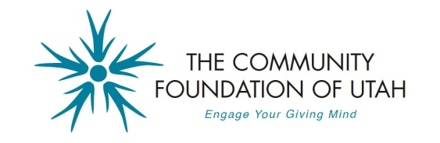
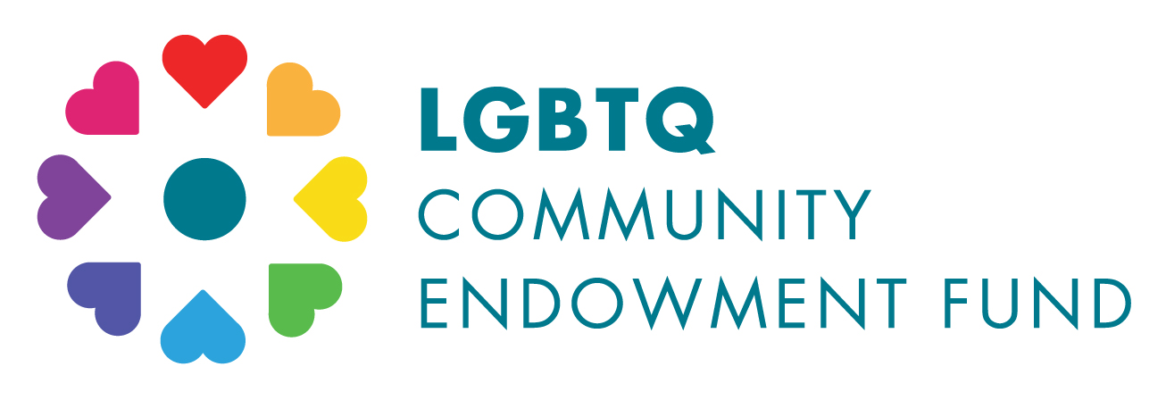

THE LGBTQ COMMUNITY ENDOWMENT FUND
2016 GRANT IMPACT REPORT

Supported by members of Utah’s LGBTQ community and their allies, the LGBTQ Endowment Fund is one of many demonstrations of the invaluable financial, artistic, and intellectual contributions made by gay and lesbian Utahans, making our state a better place for us all.

2016 GRANT RECIPIENTS
- Utah Pride Center in support of the Genderevolution Conference
- Utah AIDS Foundation for the PrEP, HIV Prevention Clinic
- Spy Hop for their Move the Dial initiative
- Westminster College for their LGBT programming intern
- UMOCA (Utah Museum of Contemporary Arts) for their Out Loud Mentoring Program
- OUTreach Resource Centers for general operating for Ogden drop-in center
- Planned Parenthood for their Safe at School Program
- Plan-B Theatre Company for the Premiere of VIRTUE by Tim Slover
- Bennion Community Service Center to support the Alternative Breaks Program
- Utah Film Center in support of the Damn These Heels! LGBT Film Festival
- Youth Futures for their shelter, drop-in services, and street outreach
- Brigham Young Queer Alumni Association for a Recognition Banquet

GRANT IMPACT
The following describes the 2016 grantees’ use of the provided funds and the resulting impact of their programs on the community.

Utah Pride Center
Genderevolution Conference - $5,000 +$1,000

At the 2016 Genderevolution Conference, Utah Pride Center provided gender diverse education to over 400 participants. As part of the conference, they developed and implemented a resource caucus to be held during lunch. We invited different mental and health care providers, attorneys, educators, and other service providers to connect with the community through mitigating the barriers to access.

The grant funds were used to help cover the cost of facility and catering costs, and to provide 76 full scholarships and 53 partial scholarships. While the conference has always provided scholarships, this year, Utah Pride Center was able to do a bigger push for young participants and were successful. The scholarships allowed them to offer all the young participants in schools and at the Utah Pride’s Youth Activity Center an opportunity to engage and challenge their own notions of gender.

Utah AIDS FOUNDATION (UAF)
PrEP, HIV Prevention Clinic - $5,000 + $500

Individuals at high risk for HIV, community members, and community healthcare providers have increased awareness of PrEP, thanks in part to the funding received. Five thousand individuals received PrEP education/awareness through group symposia, community outreach, and one-on-one HIV/STI counseling services. 139 individuals received a PrEP consultation with a healthcare provider.

All clients who were tested for HIV and STIs were provided with comprehensive, reality-based sexual health education with an emphasis on identifying and reducing personal risk. Clients taking PrEP are linked to UAF’s Adherence Counselor to help ensure they adhere to their medications and receive all necessary follow-up testing and treatment.

Spy Hop Productions
Move the Dial initiative - $3,000 + $500
(Only $500 used so far. Remaining should be used by August 31.)
Funding has been utilized towards the creation of student created media for the Move the Dial initiative. Remaining funds will be utilized towards the costs associated with staff and development workshops led by a diversity facilitator and evaluation of Spy Hop’s diversity practices with suggestions for improvement.
For this training, Spy Hop is partnering with Equality Utah to bring in Jacob Tobia for an event this summer. Jacob is a genderqueer advocate, writer, speaker, and artist dedicated to justice for the transgender, gender non-conforming, and LGBTQ communities and is a consultant on the Amazon Original Transparent.

Tremendous interest in Spy Hop’s Move the Dial initiative has been demonstrated through student engagement and media work produced. The following short list reflects specific content inspired by the Move the Dial challenge:
- One Defining Dot - The story of Alexandria’s relationship with gender identity. This film is a 2017 The America I Am film finalist and world premiered at Tribeca Film Festival and Ellis Island Celebration in April of 2017: https://vimeo.com/176536987
- Generational Men - A young, Latino teen interviews his father and grandfather to learn about what it means to be a man and what they think about gender roles for men and women: https://vimeo.com/191738766
- What is Gender - A collaborative piece between Spy Hop Productions and Raw Art Works asking the question of "what is gender?" The students went out on the streets of Boston and Lynn, MA to ask the general public about gender: https://vimeo.com/191738754

Westminster College
LGBT programming intern - $3,000 + $500
Queer Compass assisted with social integration of students by inviting and creating space and community for new students and developing relationships with Queer and ally identified Westminster Staff and faculty by having Queers and Coffee.
Queer Compass also created a space where Queer students can explore issues of gender, sexuality, marginalization, etc. by having events associated with these topics. They established that Queer Compass holds a “Brave Space” where we acknowledge that safety within the space is a goal, but it cannot be guaranteed and that for our growth as a community and as individuals is reliant upon our willingness to be vulnerable.

Queer Compass was also able to bring Fawzia Mirza to perform her one woman show Me, My Mom, and Sharmila. Fawzia speaks to intersectionality by sharing her story about how she made sense of her multiple identities (i.e., being Muslim, Lesbian, and a Canadian born Pakistani). The students and the audience were able to resonate with Fawzia about the coming out process – especially to a conservative religious family in a way that was heart felt and accessible. Not only did members have a chance to meet Fawzia and interact with her play, but the performance also created an opportunity to meet others not in Queer Compass who were also moved by her story – it allowed for a dialogue about what being an ally looks like.

Planned Parenthood Association of Utah (PPAU)
Safe at School Program - $2,000 + $1,000 to translate program into Spanish
The Safe at School program prepares school educators to play an active role in reducing harassment and bullying not only of LGBTQ students but the student body as a whole.
In the fall of 2016 Bonnie Owens, Safe at School trainer attended a training of trainers for the Teaching Transgender Toolkit. This curriculum has resources for K-12 and college educators that have been used to bolster this aspect of our curriculum.
Planned Parenthood started working with friendly districts including Salt Lake City School District to develop sample language for teachers to use in classrooms about the ways in which LBGTQ students are supported, the importance of Gay Straight Alliances in promoting student safety, and the opportunity/mandate to discuss identity in ways that more directly relate to students lived experience and needs for education in health and well being.
The additional funds allowed for materials to be translated and a culturally competent trainer is secured who will present this to the Latino community, beginning with two schools.

Plan-B Theatre Company
Premiere of VIRTUE by Tim Slover - $1,500 + $1,000

Funds were used to partially fund the world premiere of Tim Slover's VIRTUE, about the life of Hildegard of Bingen and the spiritual and intimate relationship she shared with her musical scribe Richardis. VIRTUE enjoyed a critically-acclaimed, sold-out run February 16-26, 2017, with patrons waitlisting at every performance.

Excerpts from reviews:
"a stunning portrait of an extraordinary woman" - The Salt Lake Tribune
"practically perfect in every way" - 15Bytes
"a transformative experience" - Daily Utah Chronicle
"an inspired night of theater" - Gephardt Daily
"a powerful testament to feeling what is right, rather than accepting the version of the right that someone else is trying to sell you" - City Weekly

The production spawned a partnership with St. Mark's Cathedral, our local Episcopal cathedral. Plan-B used a preview to raise funds for Hildegard's Pantry, their food pantry, as it is named for Hildegard of Bingen. They also offered a Compline service during the run of VIRTUE, featuring selections of Hildegard's music. It was the best-attended Compline service in the Catherdral’s history.

Members of the LGBTQ-Psychotherapists Guild of Utah attended a matinee performance and post-show discussion, receiving continuing education units (CEUs) toward continued licensure.

“Each season, we produce at least one world premiere that places LGBTQ issues center stage, something we will continue to do as long as we are in existence. The most recent, VIRTUE, was one of the best-received of the nearly 100 world premieres in our history.” – Jerry Rapier, Artistic Director

Bennion Center – University of Utah
Alternative Breaks Program - $1,000 + $500
During spring break, March 11-18, 2017, eleven students traveled to San Francisco, CA to engage in dialogue and reflection about the need for increased social acceptance and accessibility for the LGBTQIA community. This trip focused on gender, sexuality, identity, and social marginalization, and participants explored the intersections of those pieces. Participants also volunteered with eight community organizations that support these intersectional identities and challenge marginalization.
The funds were used to discount trip cost for all of the participants on the LGBTQIA trip to San Francisco, CA. $150 per person, making the total trip cost $550.
100% of participants self-reported they are more likely to volunteer/engage in community service in the future, that this experience increased their appreciation for those with background and experiences that are different from their own, and ability to collaborate with others. In addition, 100% stated their overall knowledge regarding the trip service issue was increased from their experience.
This group of twelve (eleven students and one staff partner) contributed over 420 volunteer hours to the San Francisco community. They helped serve approximately 1,000 guests meals, donated 50 assembled hygiene bags, created 30 journals, and prepared cotton supplies and vitamin c packets for a harm reduction center. As one community partner stated, “The students were exceptionally engaged and willing to not only work hard but learn about our work. We included a robust educational opportunity and they were interested and enthusiastic about all of our work. Their volunteer work impact our most marginalized clients and we are extremely grateful to them. We hope they come back in 2018!”

Utah Film Center (UTFC)

Damn These Heels! LGBT Film Festival - $1,000 + $1,500

The funds were used to support guest travel for 2017 Damn These Heels LGBTQ annual film festival and accompanying activities. In June 2017, Utah Film Center brought director Sam McConnell to Salt Lake City to answer questions and engage attendees at his films The Trans List and The Out List . These films were part of Damn These Heels at the Pride Festival.

The Utah Pride Center (UPC) requested film options to increase the diversity of activities at the Pride Celebration; The Out List and The Trans List, which explore the range of experiences of Trans persons and being “out” in America, helped offer introspective experiences to festival attendees. In supporting UPC weekend activities, the event also allowed UTFC to engage festival attendees and market the Damn These Heels film festival to broad, invested community that supports and celebrates LGBTQ issues and history.

Youth Futures Shelter Home
Shelter, drop-in services, and street outreach - $1,000 + $2,000
The funding was key in helping Youth Futures to meet its mission to service homeless, unaccompanied, runaway and at-risk youth in Northern Utah. One of the goals this year was to hire a Community Outreach Coordinator. The position was an important step in creating additional awareness in the community, in schools and on the streets. With the funding, Youth Futures was able to fill this position, which has been an integral part of expanding the street outreach program, increasing the National Safe Place sites and presenting the program in schools.
The opportunity to reach more youth, especially LGBT youth in the schools and throughout the community continues to be a challenge. Youth are slow to trust adults they come in contact with on the street and in school. Having a consistent staff person connecting with youth in the community will increase Youth Future’s success in the future.

UMOCA
OutLoud Mentoring Program - $2,500 + $500
The grant helped fund the 10-week education outreach program, Out Loud. This program helped 11 LGBTQ+ teens confront their feelings of helplessness, isolation, and confusion. Both they and their allies were encouraged to use art as a healthy form of expression and as a tool to exchange information concerning the issues facing the LGBTQ+ community in Utah, all while enhancing the participant’s understanding of contemporary art as a whole.
Four past Out Loud participants expanded their engagement in the program by serving as Peer Mentors. These Peer Mentors attended three planning meetings prior to Out Loud to help select visiting artists and market the program to other youth. In addition to serving as resources for participants during the workshops, each Mentor developed and facilitated their own hands-on activity. The activities that helped the group address a facet of the theme of identity, included: collages of the various aspects of one’s identity; seed bombs that represented the process of acceptance and growth; stitched-together fabric masks for exploring unfamiliar aspects of one’s identity; and stop-motion .gifs that “queered” everyday objects.
Additionally, local artist and social justice advocate Yasin Fairley was commissioned for the creation of a performance to kick-off the open application period for Out Loud. The work, entitled When Flesh Becomes Matter: Bodies Unbounded, took place in mid-November in UMOCA’s Main Gallery, responded to the artworks of the exhibition, Object[ed], as well as current issues of race, gender, and sexuality. In addition to being free to the public and highly attended by the community at-large, Flesh Becomes Matter was attended by past Out Loud participants and their friends, several of whom subsequently applied to the program or connected others in their networks to program information. Yasin Fairley returned to UMOCA during Out Loud to lead a youth workshop on movement and the intersectionality of identities.

